**Project Design Phase-II**

**Technology Stack (Architecture & Stack)**

|  |  |
| --- | --- |
| Date | 10 June 2025 |
| Team ID | LTVIP2025TMID59165 |
| Project Name | Citizen AI – Intelligent Citizen Engagement Platform |
| Maximum Marks | 4 Marks |

**Technical Architecture:**

The Deliverable shall include the architectural diagram as below and the information as per the table1 & table 2

**Example: Order processing during pandemics for offline mode**

|  |  |  |  |
| --- | --- | --- | --- |
| **S.No** | **Component** | **Description** | **Technology** |
|  | User Interface | How user interacts with application e.g.  Web UI, Mobile App, Chatbot etc. | HTML, CSS, JavaScript / Angular Js / React Js etc. |
|  | Application Logic-1 | Logic for a process in the application | Java / Python |
|  | Application Logic-2 | Logic for a process in the application | IBM Watson STT service |
|  | Application Logic-3 | Logic for a process in the application | IBM Watson Assistant |
|  | Database | Data Type, Configurations etc. | MySQL, NoSQL, etc. |
|  | Cloud Database | Database Service on Cloud | IBM DB2, IBM Cloudant etc. |
|  | File Storage | File storage requirements | IBM Block Storage or Other Storage Service or Local Filesystem |
|  | External API-1 | Purpose of External API used in the application | IBM Weather API, etc. |
|  | External API-2 | Purpose of External API used in the application | Aadhar API, etc. |
|  | Machine Learning Model | Purpose of Machine Learning Model | Object Recognition Model, etc. |
|  | Infrastructure (Server / Cloud) | Application Deployment on Local System / Cloud  Local Server Configuration:  Cloud Server Configuration : | Local, Cloud Foundry, Kubernetes, etc. |

**Table-2: Application Characteristics:**

| **S.No** | **Characteristics** | **Description** | **Technology** |
| --- | --- | --- | --- |
|  | Open-Source Frameworks | List the open-source frameworks used | Technology of Opensource framework |
|  | Security Implementations | List all the security / access controls implemented, use of firewalls etc. | e.g. SHA-256, Encryptions, IAM Controls, OWASP etc. |
|  | Scalable Architecture | Justify the scalability of architecture (3 – tier, Micro-services) | Technology used |
|  | Availability | Justify the availability of application (e.g. use of load balancers, distributed servers etc.) | Technology used |
|  | Performance | Design consideration for the performance of the application (number of requests per sec, use of Cache, use of CDN’s) etc. | Technology used |

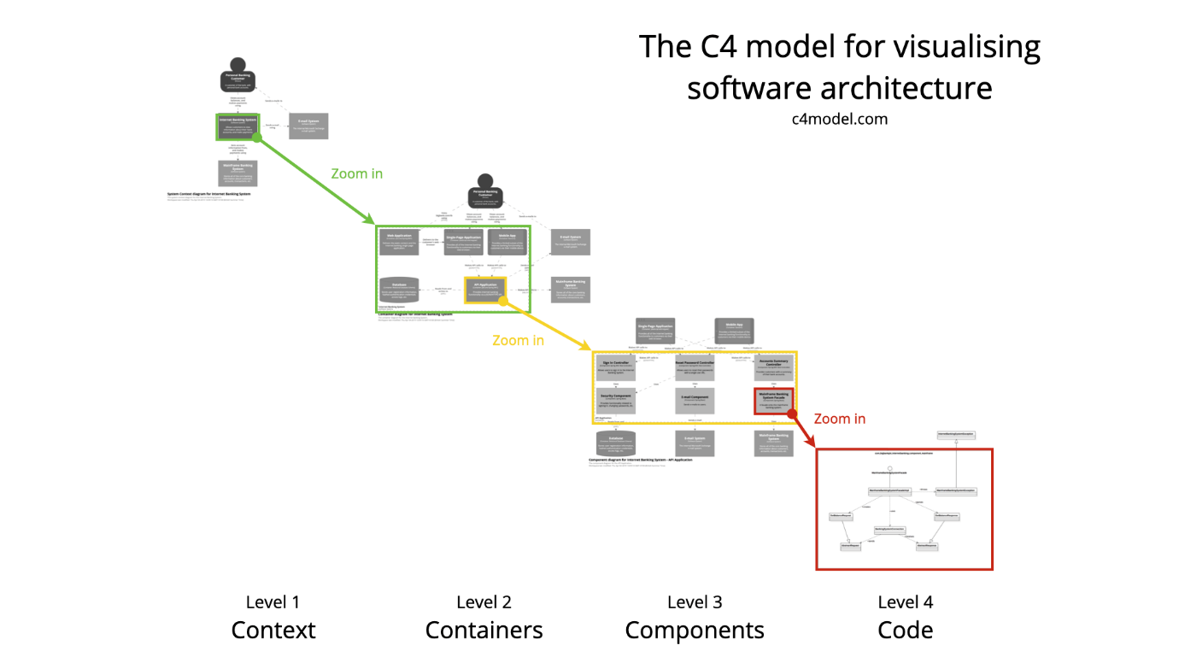

The C4 model was created as a way to help software development teams describe and communicate software architecture, both during up-front design sessions and when retrospectively documenting an existing codebase. It’s a way to create “maps of your code”, at various levels of detail, in the same way you would use something like Google Maps to zoom in and out of an area you are interested in.